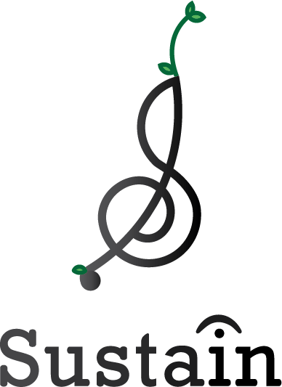
For Immediate Release: May 26, 2020
Betsy Mortensen
Sustain Music & Nature
betsy@sustainmusicandnature.org
860-462-3038

Concerts Continue at Colorado’s Public Lands
Nonprofit highlights music and parks in a COVID-safe way

Fort Collins, CO: Sustain Music and Nature, a nonprofit that harnesses music to generate support for the environment, announces the second annual Sagebrush Sessions starting June 7, 2020. Sagebrush Sessions are a monthly summer series of free concerts at public lands along the Front Range of Colorado. Sagebrush Sessions introduce residents to their local natural areas and musicians, to increase public support for both. In consideration of the COVID-19 crisis, the series will have limited attendance, enforced social distancing between households, and no naturalist-guided hiking portion.

The line-up for the 2020 Sagebrush Sessions:
- June 7 - Brent Cowles and Kid Astronaut at Rocky Mountain Arsenal National Wildlife Refuge
- July 19 - Thunder & Rain, Daniel Rodriguez and Taylor Shae at Walker Ranch, Boulder County Open Space
- August 30 - Slow Caves and Silver & Gold at Golden Gate Canyon State Park
- September 20 - Tierro Band with Bridget Law, Annie Oakley and Stevey Ertl at Lory State Park

The mission of Sagebrush Sessions is to build support for bands and public lands. 50% of 2019 participants had never previously heard of the musicians we featured or visited Sagebrush Session locations before.

Why public lands? Over 43% of Colorado lands belong to the public. National forests, wildlife refuges, parks, and historic sites provide places of recreation, industry, reflection, and preserve our histories. Yet they’re at risk. Growing political movements are working to sell off public lands for short-term gain, at the expense of our shared American inheritance.

“The whole event was really wonderful and well put on. I enjoyed the entirety of it, meeting the musicians and connecting with other like-minded folks,” noted one of last year’s audience members. “Sagebrush Sessions have been really effective at introducing people to both their parks and to the incredible musicians that call Colorado home,” says Sustain Music & Nature co-founder, Betsy Mortensen. “We know that people are hungry for live music again and we’re excited to offer these concerts in a limited, distanced way.”

To adhere to rapidly changing health guidelines, the number of participants will be limited according to current state and county orders. Ticket reservations will be announced on sustainmusicandnature.org/2020. All households will be required to sit at least 6 feet apart from other household groups. No one experiencing COVID-19 symptoms will be allowed to participate.

Sustain Music and Nature: Sustain Music and Nature is a 501c3 nonprofit that makes music a force for nature. Since 2015, Sustain has worked across the US with musicians and environmental organizations to amplify public support for environmental causes. Based in Fort Collins, CO. Visit sustainmusicandnature.org to learn more.

###
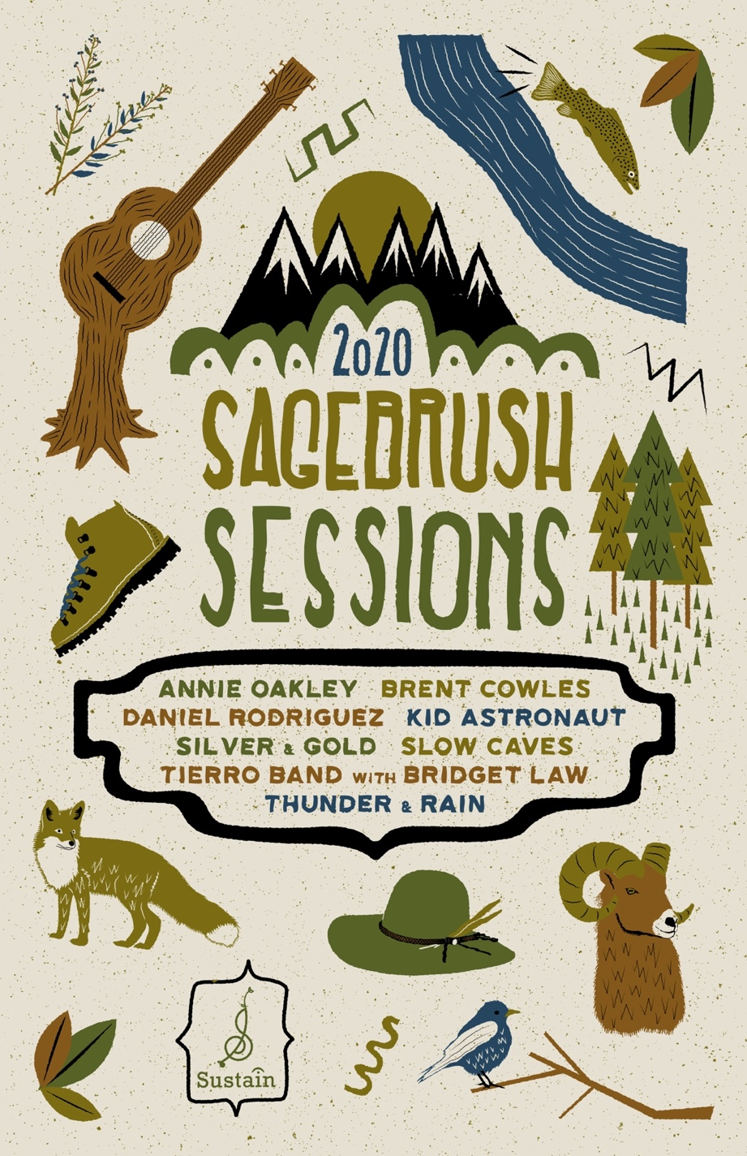

Scenes from last year’s Sagebrush Sessions (pre-social distancing)
(full files available here: https://app.swivle.com/?r=us-east-1/#/s/YVmxRiz/bohemiancompanies

